**TECHNICAL NOTES**

1. **Introduction**

This document reports on the development of the tool which

* translates the outputs from a microsimulation road traffic model (developed in Aimsun) into tables in a MySQL database required for carrying out a MOVES simulation of road traffic emission at Project Scale
* loads user selected meteorology data into the above MySQL database
* prepares a runspec file which is an xml file summarizing inputs and settings of the MOVES simulation and is required for the execution of the simulation.

The following section describes the assumptions and technical details in constructing the MOVES input tables in MySQL database. The Python scripts for constructing these tables are available on the project [Github repository](https://github.com/nnhuynh/Traffic-Emission-Modelling-Interface).

1. **Table construction**

**2.1 Initiating MySQL tables for MOVES**

The MySQL tables required for running a MOVES simulation at the Project Scale are marked with an x in the column ‘Project Data Manager’ in the below table (page 33 in the [2014a MOVES User Interface Reference Manual](https://nepis.epa.gov/Exe/ZyPDF.cgi?Dockey=P100Q3C1.pdf))

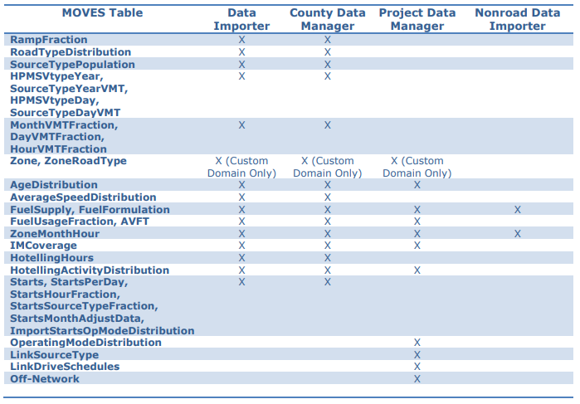

The SQL command to create each of these MySQL tables is available on [MOVES Algorithms](https://www.epa.gov/moves/moves-algorithms) webpage.

Among the 14 tables required for a generic MOVES simulation at the Project Scale, the 6 tables below are considered not within the scope of the traffic emission modelling in this project (and are also not critical to running the simulation), thus will be empty.

* Tables ‘Zone’ and ‘ZoneRoadType’
* Table ‘IMCoverage’
* Table ‘HotellingActivityDistribution’
* Table ‘LinkDriveSchedules’
* Table ‘Off-Network’

**2.2. Prepare table “ZoneMonthHour”**

The data was daily weather observation data available from the NSW Office of Environment and Heritage (OEH) [website](https://www.environment.nsw.gov.au/AQMS/search.htm). It includes hourly averages for all meteorology variables for most stations (51 stations as of July 2019) in the OEH air quality monitoring network. To populate values in table “ZoneMonthHour” in MySQL database, only the data of relative humidity and temperature was used.

**2.3 Prepare table “AgeDistribution”**

The data of year of manufacture by vehicle age of registered vehicles for all of NSW was used. This data was available from [RMS website](https://www.rms.nsw.gov.au/cgi-bin/index.cgi?fuseaction=statstables.show&cat=Registration) for each quarter from Q2/2000 to most recently (which was Q2/2019 at the time of this report).

The below assumptions were made in processing this dataset

* The mapping between RMS vehicle types and MOVES source types follow the below table

|  |  |  |
| --- | --- | --- |
| RMS types | MOVES types | MOVES number |
| Passenger Vehicles | Passenger Car | 21 |
| Off-road Vehicles | Passenger Truck | 31 |
| People movers | Transit Bus | 42 |
| Small Buses | Transit Bus | 42 |
| Mobile Homes | Motor Home | 54 |
| Motor cycles | Motorcycle | 11 |
| Scooters | Motorcycle | 11 |
| Light Trucks | Light Commercial Truck | 32 |
| Light Plants | Light Commercial Truck | 32 |
| Light Trailers | Motorcycle (with a factor) | 11 |
| Other Vehicles | Not included |  |
| Buses | Transit Bus | 42 |
| Heavy Trucks | Single Unit Short-haul Truck | 52 |
| Prime Movers | Single Unit Short-haul Truck | 52 |
| Heavy Plants | Combination Short-haul Truck | 61 |
| Heavy Trailers | Not included |  |

* In the original RMS data, value of “Unknown” manufacturing year in each vehicle category are prorated to all years of that category. RMS vehicle category ‘Others’ is not ignored. The total value of this category is very small (158) compared to the total number of registered vehicles (approximately 6.6 millions).
* RMS vehicle category ‘Heavy Trailers’ was ignored as they represented a small fraction of all registered on-road vehicles (less than 1% as of Q1/2019) and do not directly and significantly contribute to on-road emission.
* RMS vehicle category ‘Light Trailers’ represented approximately 14% of all registered on-road vehicles (as of Q1/2019) and may contribute considerably to on-road emissions in terms of tyre and road wear. Because MOVES does not have a dedicated category for trailers, this RMS vehicle category is grouped into MOVES vehicle type ‘Motorcycle’ using a scaling factor which can be provided by users. The default value of this factor is 0.1, which means that 1 the RMS ‘Light Trailers’ vehicle is equivalent to 0.1 MOVES ‘Motorcycle’ vehicle.
* RMS vehicle category ‘Other Vehicles’ represented a very small fraction of the total registered vehicles (158 out of over 6.6 million as of Q1/2019) and was ignored.

**2.3 Prepare tables “LinkSourceTypeHour” and “OperatingModeDistribution” from Aimsun outputs**

Sample output tables from the Aimsun model for the Wollongong City Council were used (i) to populate values for table “LinkSourceTypeHour” and (ii) to prepare input values required to construct table “OperatingModeDistribution”.

* + 1. Prepare table “LinkSourceTypeHour”

This table has three columns, including link ID, source type ID (i.e. MOVES vehicle type ID as shown in the table in Section 2.3), and the percentage of time each source type ID spent on the corresponding link ID. The values of this table were calculated from the summary of simulated vehicle paths from the Aimsun simulation model outputs (see Section 2.3.2.1).

* + 1. Prepare table “OperatingModeDistribution”

Populating values in table “OperatingModeDistribution” requires the following inputs:

* a summary of simulated vehicle paths in the Aimsun traffic simulation model.
* a summary of average time on each link of all simulated vehicles in the Aimsun traffic simulation model.
* VSP_vehicle
* The Composite Urban Emissions Drive Cycle (CUEDC) for petrol and diesel vehicles which were representative of real world Australian urban driving and were developed for four types of road segment, namely residential, arterial, freeway and congested.

2.3.2.1 Prepare summary of simulated vehicle paths

This summary table has six columns, including vehicle ID, path ID (for each vehicle ID which may make more than one path in the simulation), link ID, the ordinal number of link ID in the current path ID, the time vehicle ID enters link ID, and the time vehicle ID spent on link ID. The Aimsun output table “mivehdetailedtrajectory” was used for this purpose. This table contains detailed trajectory of the path(s) of each vehicle included in the model. Position of the vehicles are recorded in each row at fixed intervals. In the sample data provided by Arif in July 2019, this interval is 0.8 second. In generating moves_proc.csv, the time a vehicle enters a link is the time that vehicle first recorded on that link, and the time the vehicle spent on the link equals time difference between when it was first and last recorded on the link. Due to the fixed time interval of 0.8 second between records in table “mivehdetailedtrajectory”, the minimum time a vehicle staying on a link is assumed 0.8 seconds.

2.3.2.2 Prepare summary of average time on links

This table has three columns, including link ID, link type, and average time on link. For the Wollongong case study, because the Aimsun models covers only a limited area in the Wollongong CBD, all links were assumed residential (i.e. MOVES road type 5). The average time on a link was calculated from the summary of simulated vehicle paths as the total time simulated vehicles staying on the link (in seconds) divided by the number of these vehicles.

**2.4 Prepare fuel related tables**

These tables include ‘FuelSupply’, ‘FuelFormulation’, ‘FuelUsageFraction’, and ‘AVFT’ (Alternative Vehicle and Fuel Technologies).

**2.4.1 Prepare table ‘FuelFormulation’**

The default table ‘FuelFormulation’ which came with MOVES 2014a will be used. Please note that NULL values exist in the default table and were replaced by -1 in the newly created FuelFormulation table.

**2.4.2 Prepare table ‘AVFT’**

The data of motive power by vehicle type of all registered vehicles was used. This data was available from [RMS website](https://www.rms.nsw.gov.au/cgi-bin/index.cgi?fuseaction=statstables.show&cat=Registration) quarterly from Q2/2000 to Q2/2019 (at the time of this report). The RMS vehicle types in this data set were grouped into MOVES vehicle types following the method described in Section 2.3 “Prepare table AgeDistribution”.

Below is the summary of the mapping from the motive power types in the RMS data to the MOVES fuel type used in preparing the table ‘AVFT’. It also includes our assumption on the Engine Technology ID, which is required as part of the AVFT table, for each MOVES Fuel Type.

|  |  |  |  |
| --- | --- | --- | --- |
| **RMS Motive Power** | **MOVES Fuel Type** | **MOVES Fuel Type ID** | **Engine Tech ID** |
| Unleaded Petrol | Conventional Gasoline | 1 | 1 |
| Petrol | Conventional Gasoline | 1 | 1 |
| LPG | Conventional Gasoline | 1 | 1 |
| Electric/Petrol | Conventional Gasoline | 1 | 1 |
| Electricity | Electricity | 9 | 30 |
| Petrol And LPG (Dual Fuel) | Conventional Gasoline | 1 | 1 |
| Diesel | Conventional Diesel Fuel | 2 | 1 |
| Diesel And LPG (Dual Fuel) | Conventional Diesel Fuel | 2 | 1 |
| Diesel & LPT (Torque Topping) | Conventional Diesel Fuel | 2 | 1 |
| Diesel/NAT | Conventional Diesel Fuel | 2 | 1 |
| Compressed Natural Gas | Compressed Natural Gas (CNG) | 3 | 1 |
| Petrol & Compressed Natural Gas | Conventional Gasoline | 1 | 1 |
| Liquid Natural Gas | Compressed Natural Gas (CNG) | 3 | 1 |
| Hydrogen | Compressed Natural Gas (CNG) | 3 | 1 |
| Kerosene | Conventional Gasoline | 1 | 1 |
| Petrol & Kerosene (Dual Fuel) | Conventional Gasoline | 1 | 1 |
| Steam (Fuel Oil Powered) | Conventional Gasoline | 1 | 1 |
| Steam (Petrol Powered) | Conventional Gasoline | 1 | 1 |
| Steam (Diesel Powered) | Conventional Diesel Fuel | 2 | 1 |
| Steam (Coal Burning Powered) | Conventional Diesel Fuel | 2 | 1 |
| Unknown | Not included | Not included |  |
| No engine | Not included | Not included |  |

The total number of vehicles of RMS motive power types ‘Unknown’ and ‘No engine’ of each vehicle type is prorated to other types of motive power of the corresponding vehicle type.

**2.4.3 Prepare table ‘FuelUsageFraction’**

As stated in the MOVES2014a Technical Guidance, the default values for tables FuelUsageFraction should be used except for when local data are available that indicate different E-85 usage. In such a case, the fraction of gasoline (fuelSupplyFuelTypeID=1) and E-85 (fuelSupplyFuelTypeID=5) can be specified for sourceBinFuelTypeID = 5.

Because E-85 is not available anywhere in Australia, the newly created table FuelUsageFraction will take the MOVES default values, except for sourceBinFuelTypeID = 5 where the usageFraction corresponding to gasoline (fuelSupplyFuelTypeID=1) will be 1, and that corresponding to E-85 (fuelSupplyFuelTypeID=5) will be 0.

**2.4.4 Prepare table ‘FuelSupply’**

The data of Sales of Petroleum Products by State Marketing Area for NSW available from the [Australian Petroleum Statistics](https://www.energy.gov.au/government-priorities/energy-data/australian-petroleum-statistics) (APS) for 2019 was used in preparing table ‘FuelUsageFraction’. A screenshot of the data for the first half of 2019 is provided in the picture below

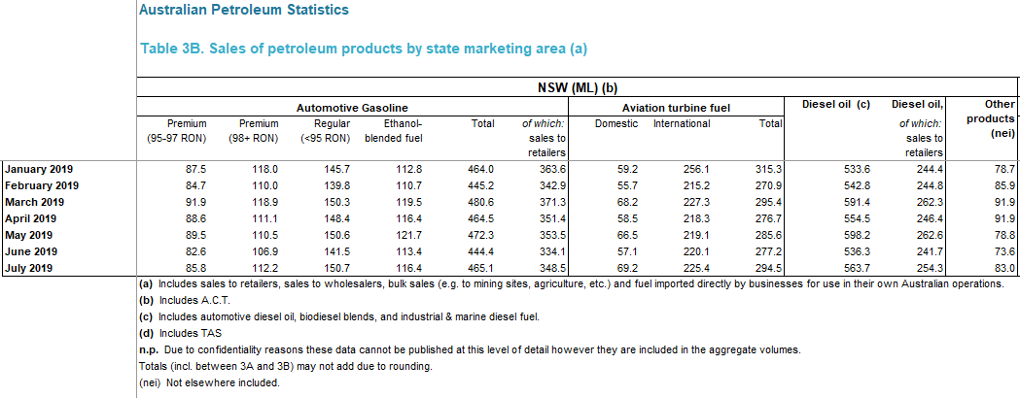

The following table summarises the mapping between the petroleum reported in the APS data to the MOVES fuel type.

|  |  |  |  |  |
| --- | --- | --- | --- | --- |
| **APS fuel type** | **fuelSubtypeID** | **fuelSubtypeDesc** | **FuelFormulationID** | **FuelTypeID** |
| 95-97 RON | 10 | Conventional Gasoline | 10 | 1 |
| 98+ RON | 10 | Conventional Gasoline | 10 | 1 |
| <95 RON | 10 | Conventional Gasoline | 10 | 1 |
| Ethanol-blended fuel | 12 | Gasohol (E10) | 1002 | 1 |
| Diesel oil | 20 | Conventional Diesel Fuel | 20 | 2 |
| Other products | Not included | | | |

Aviation turbine fuel was excluded in the preparation of the Fuel Supply table because only on-road traffic is considered in the scope of this work.

Please also note that category “Other products” in the APS data was not included. However, while this category accounts for only 6.2% of all petroleum volume sold in NSW in July 2019, it should be included in the input into MOVES simulation if/once information of its composition becomes available.

As stated in the MOVES2014a Technical Guidance in preparing for the Fuel Supply table, “within each fuel type, multiple fuel formulations can be listed as long as the market share sums to one”.